Jacob Englund

Professor Graham

CS 330

11 December 2024

Final Project Reflection

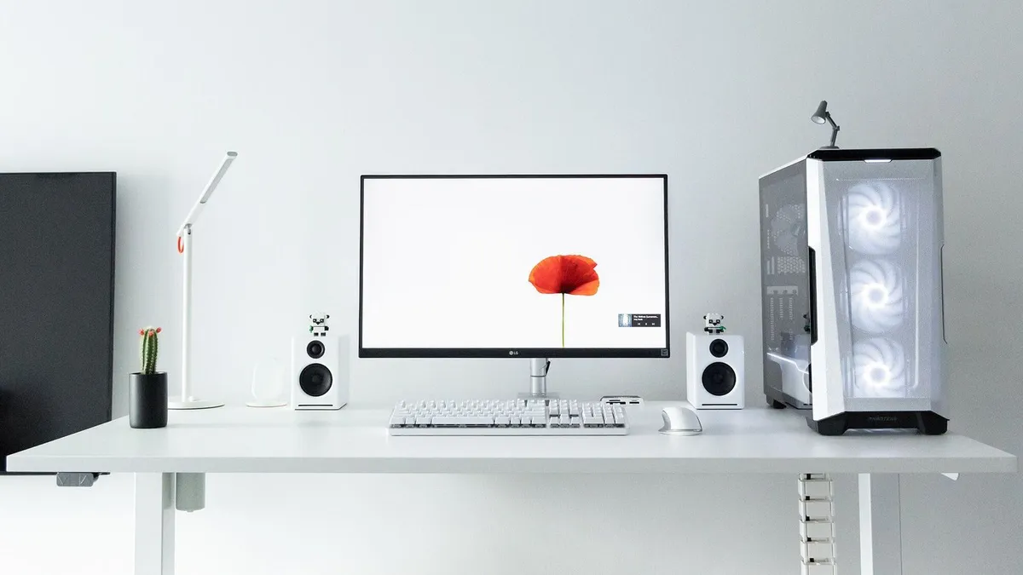

**Justify development choices for your 3D scene:**

The objects I chose for the scene above were objects I felt comfortable working with with my limited knowledge of OpenGL. These objects included a desk, computer, speakers, monitor, and light. The two complex objects were the monitor and light. These objects required multiple pieces to be put together to create the final product. These were more challenging, but possible to complete making for a fun challenge.

**Explain how a user can navigate your 3D scene:**

The 3D scene controls are basic and easy to use. WASD keys are used for movement. W and D control the forward and backward movements. S and D control the left and right movements. To control the speed of the camera, a control was added to the scroll wheel. In addition to the WASD movement keys, there are keys to move the camera up and down. The Q key moves the camera up while the E key moves the camera down. Scrolling up increases the movement speed while scrolling down decreases it. There are also two keys that can be used to switch perspectives. The O key enables an orthographic mode while the P key enables a perspective mode. These controls allow the viewer to interact with the environment in any way they choose.

**Explain the custom functions in your program that you are using to make your code more modular and organized:**

There are a lot of moving pieces in a 3D scene. Each of these pieces can be simplified to make modeling easier. The two big functions that I added were the SetShaderTexture and SetShaderMaterial functions. The SetShaderTexture function allows for easy texture mapping to 3D objects that have been created. Rather than individually setting texture properties for every object in a scene, this function allows for the user to set a texture with just a code word. For example, the desk has a texture different from the monitor. By putting the code word “desk” in the texture function, the program knows to set the desk texture differently than the monitor. The SetShaderMaterial function does something remarkably similar, but for the material of the object. Each material has different properties allowing the light to interact with it in diverse ways. A shiny piece of metal in the scene should be different than a dull piece of wood. This function allows the user to easily switch between varied materials without having to set each object's individual properties separately.